[COMPANY NAME]
Mailbox Compromise Response Playbook
Business Confidential. Not to be distributed

VERSION HISTORY
VERSION | DATE | NAME | DESCRIPTION
Playbook owner:
Next review:

Contents
1.1. Detection 3
1.2. Roles and responsibilities 3
1.3. Response steps 3
2. Annex A: Mailbox compromise response flow diagram 6

Mailbox Compromise Response Playbook

Detection
A mailbox compromise occurs when an unauthorised party has successfully accessed the [EMAIL PLATFORM ] and/or mailbox of one or more [COMPANY NAME] employees or other users.
A mailbox compromise may be detected, amongst other methods, by:
- Sign-ins or other [EMAIL PLATFORM ] account activity identified as suspicious by the [Service Desk or IT Security Team.
- Reported unusual and/or unauthorised activity within a user's mailbox or other [EMAIL PLATFORM ] resources.
- Reported emails sent from a user's [EMAIL PLATFORM ] account which are considered suspicious or determined not to have been sent by the legitimate owner of that account, for example attempted invoice fraud.
- Multiple MFA prompts sent to user to confuse and fatigue the account holder.

Roles and responsibilities
- Cyber Security Incident Response Team (CSIRT) roles and responsibilities are defined in Section 3 of the Cyber Security Incident Response Plan.
- The IT Security Team will typically lead any initial technical response, supported if necessary by an external cyber response provider.

Response steps
A diagram providing additional guidance is included at the end of this Playbook.

Mitigation
Although no security control can guarantee complete protection against a mailbox compromise attack, adopting several layers of defence greatly reduces the likelihood of a successful attack. The following should be implemented:
- Enforce MFA for all users on the email tenant. Whilst this is not a silver bullet, it can deter the less sophisticated threat actors from successfully authenticating. However, to prevent sophisticated phishing attacks which often lead to a mailbox compromise, the following MFA implementations are better than others:
  - If possible, use a FIDO2-certified authenticator. Examples of this would respectively be Windows Hello for Business or a YubiKey.
  - Combine best practice MFA with conditional access policies to require authenticating devices to be trusted or compliant and come from trusted locations.
  - Avoid using application-based MFA with push notifications where possible, as these may be subject to notification fatigue attacks.
  - Avoid using MFA solutions based on SMS or a one-time password via authenticator applications as these are vulnerable to multiple methods of interception.
- Disable legacy email protocols that are not strictly required for business purposes. Legacy email protocols allow a threat actor to bypass MFA and download a portion of the mailbox to a local client.
- Monitor the dark web for any credentials that are leaked. If a user is identified in a breach, swiftly change their password.
- Consider disabling the ability for external tenants to start chats with users in Teams if not required for the business.
- As always, conduct regular phishing awareness training and phishing simulations. Ensure that these match the current levels of attack sophistication, where possible.
- Consider DMARC to prevent unauthorised individuals from sending phishing emails using your organisation's domain.

Initial containment
Upon detection of a mailbox compromise, the IT Security Team should:
- Disable access to potentially compromised accounts;
- Revoke session access for those accounts
- Enforce a password change for the compromised account(s).
- Conduct a check of mailbox rules to ensure there are not any forwarding rules in place, among other potential unauthorised rules the threat actor may have established.
- Ensuring that any persistence mechanisms (including altered access permissions, mailbox/forwarding rules, application permissions, or device-based malware installation) are remedied.
These steps may need to be repeated if additional compromised accounts are identified later.

Escalation
The Incident should be triaged and escalated, as per Section 4.2 of the Cyber Security Incident Response Plan.

Evidence collection
Relevant evidence could include:
- [RECORD NAME] logs from [COMPANY NAME] [EMAIL PLATFORM ], and any other relevant logs from [COMPANY NAME] [EMAIL SECURITY] platform.
- Other relevant settings and permissions within [COMPANY NAME’S] [EMAIL PLATFORM ].
- Mail logs from [COMPANY NAME] [EMAIL PLATFORM ] and/or [EMAIL SECURITY] PLATFORMs.
- Copies of emails potentially sent or received by compromised accounts.
- Statements by relevant [COMPANY NAME] users or third-party email recipients.
Initial analysis of evidence can often be conducted directly within the [EMAIL PLATFORM ] platform.
However, if a mailbox compromise has occurred, evidence regarding the Incident should be captured at an appropriate time and stored securely to prevent its loss. This includes emails (to avoid deletion) and relevant [RECORD NAME] logs (to avoid loss of data through rollover).
Evidence capture should be actioned by the IT Security Team and/or an external cyber response provider. Additional evidence retention may be recommended by legal counsel.

Analysis
Available evidence should be reviewed by the IT Security Team and/or an external cyber response provider, to determine as far as possible:
- How many [COMPANY NAME] [EMAIL PLATFORM ] accounts were compromised, and for what period of time.
- How [COMPANY NAME] accounts were originally compromised.
- What activity the attacker conducted using the compromised account(s).
- What data has been viewed or retrieved by the attacker.
- What persistence mechanisms, including new accounts, accesses, mailbox/forwarding rules, application permissions, or device-based malware installation, were employed by the attacker within [COMPANY NAME] PLATFORMs.
Findings should be reported regularly to relevant members of the [Management Team]. In addition, if additional compromised accounts or persistence mechanisms are discovered, these should be reported immediately to the IT Security Team] for containment.
If a data incident is identified, this should be managed appropriately, as per the Data Incident Response Playbook.

Eradication
Any compromised accounts should be secured against further unauthorised access before user access is restored. This includes:
- Ensuring that appropriate security controls (including multi-factor authentication, appropriate access policies, etc) are in place to mitigate the risk of further compromise.
- Ensuring that the user is aware of any ongoing potential risks relating to the Incident, and, if appropriate, deleting relevant phishing or other malicious emails from user mailboxes.
Either during the response, or during the subsequent post-incident review (see below), recommended improvements may be identified which will improve the overall security of [COMPANY NAME] [EMAIL PLATFORM ] environment and/or reduce the risk of similar incidents occurring in the future. The Cyber Security Lead should assess the viability, impact and cost of any such recommended improvements, and determine whether they should be applied, and/or whether the cost or business impact of the decision requires escalation to additional [COMPANY NAME] decision-makers.

Recovery
Restoration of access to individual accounts can proceed once any persistent threat has been eradicated.

Post-incident review
For Incidents classified as P1 to P3, a post-incident review should be completed, as per Section 4.7 of the Cyber Security Incident Response Plan.

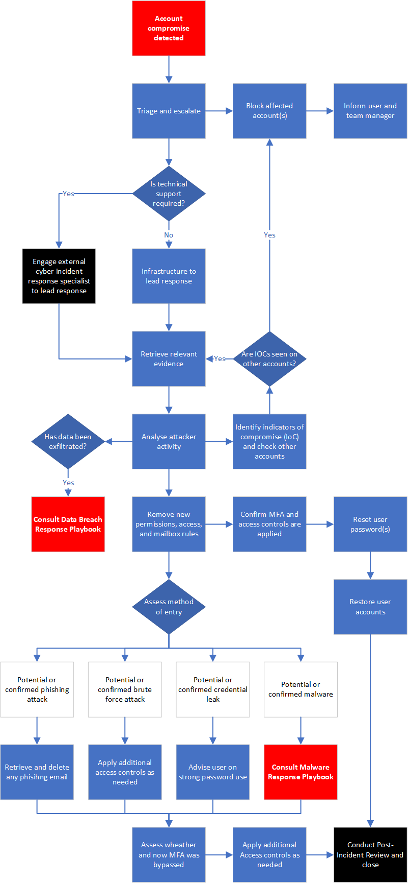
Annex A: Mailbox compromise response flow diagram

