[COMPANY NAME]
Malware Response Playbook
Business Confidential. Not to be distributed

VERSION HISTORY
VERSION | DATE | NAME | DESCRIPTION
Playbook owner:
Next review:

Contents
1.1. Detection 3
1.2. Roles and responsibilities 3
1.3. Response steps 3
2. Annex A: Malware Response Flow Diagram 5

Malware Response Playbook

Detection
Malware is software designed and employed for malicious purposes, such as compromising or damaging systems, spying, theft of funds or data, or otherwise conducting unauthorised activity. Malware could be deployed onto systems via various methods and for a variety of reasons and is frequently deployed as part of a larger cyber-Incident.
Malware may be detected, amongst other methods, by:
- Affected device owner detection
  - The device owner informs the IT team that they interacted with a malicious link and/or document
  - As above, but the user activity has resulted in a file or similar being downloaded to the device
  - Unexpected or unusual device activity is observed
  - Identification of new and unexpected software/services on the device
  - The user cannot access their device or files contained on it.

- Other detection
  - Anti-Virus provider alerting and potential quarantine of suspicious artefacts
  - Detection through third party software provider
  - Firewall provider logs and alerting mechanisms
  - Unexpected communication coming from the affected device such as spam emails and escalation of privileges requests
  - A law enforcement representative or other entity may approach stating malicious traffic or similar has been detected emitting from company infrastructure
  - IT admin team manual detection.

- SIEM and/or SOAR alert detection
  - The device trying to run or install the malware may trigger alerts in security monitoring systems. Both directly because of recognised malicious code being run on the device and also indirectly due to an action being carried out by the malware.
  - Such as creating command-and-control activity and/or initiating unexpected commands through PowerShell etc. Additional alerts that may be observed in a SOC/SIEM platform may include:
    - Lateral movement activity detected
    - Low reputation code detection
    - Suspicious PowerShell Commands
    - Privilege escalation activities and/or new account creation
    - Command-and-control traffic detected
    - Installation of executables
    - Specific tool detection e.g., MimiKatz, Cobalt Strike etc.
    - Data incident prevention alerts.

Roles and responsibilities
- Cyber Security Incident Response Team (CSIRT) roles and responsibilities are defined in Section 3 of the Cyber Security Incident Response Plan.

Response steps
A diagram providing additional guidance is included at the end of this Playbook.

Triage
Initial reactive actions to establish its extent/impact and its severity include:
- Initial verification
  - Review the detection mechanism (e.g., SOC/SIEM alert, User or files encrypted)
  - Establish initial delivery mechanism (if possible)
  - Determine related user account(s)
  - Identify the initial scope of the infection (how many devices and if its propagating)
  - Identify if the malware was actioned (quarantined/blocked) by any anti-malware function
  - If delivery mechanism through email, check for other recipients.

- Assess Business Impact
  - Where daily business operations may be affected, business continuity plans should be invoked to mitigate the impact on operations based on the severity of the incident

- Document initial IoC’s
  - Identify and note any initial indicators of compromise (IoC) observed during triage
    - IP Addresses
    - URLs (and redirections)
    - Domains
    - Websites
    - Executable name/type (dll, msi, exe or other)
    - File names
    - File hashes
    - Email subject
    - Email sender (also check headers)

- Establish an initial timeline of events
  - Note pertinent points such as:
    - Affected users and endpoints (extent of the infection)
    - Identified malicious behaviour on affected device(s)
    - Other affected assets
    - Timestamps of relevant actions (e.g. detected, when device(s) was isolated)
    - Impact of the unavailability of the asset(s)
    - Note a brief statement from affected users and device owner of the actions they carried out e.g., Opened attachment, interacted with sign-in pages.

Escalation
- The incident should be escalated, as per Section 4.3 of the Cyber Security Incident Response Plan.

Containment
Depending on the type of malware present, some initial containment may be necessary as a precaution, including isolation of potentially affected devices from [COMPANY NAME] networks to prevent further infection, and/or from the internet to restrict any further attacker access or command and control. Further containment actions include:
- Update anti-malware and firewall solutions, ensuring that the indicators of compromise identified during the triage and analysis phase are deployed on antimalware and firewall solutions.
- Initiate an estate wide antimalware scan.
- Where possible a tactical security operations centre (SOC) or enhanced monitoring system should be established to ensure no further infection or reinfection takes place
- Where user accounts have been identified as compromised or ‘at risk’, access to the account should be blocked pending further investigation.
- Where sensitive accounts have been identified, a less aggressive method could be employed by forcing MFA / Password reset for the affected account.
  - Caution should be exercised with this latter approach as the adversary may have access to the account to perform the reset action themselves. Accounts following the less aggressive method should be monitored for access and activity.
- Where a user account has been blocked, all active sessions the user currently has should be revoked to prevent further access to the account. This action will prevent the adversary from accessing the account
- Network share protocols such as SMB should be disabled to prevent the adversaries from laterally moving within the network environment.
- Remote access systems such as remote desktop protocol (RDP) are a common attack vector for adversaries as are website admin portals. Disabling or allow listing access to these portals can prevent unauthorised access and assist in containing an incident.

Evidence collection
Secure capture of a copy of any malware, particularly where the malware is unidentified and/or may potentially have facilitated unknown activity on [COMPANY NAME] devices, may be appropriate if analysis could be required, and should be conducted as soon as possible so deletion and eradication can occur.
Any malware should be treated with cautionand retrieved and stored using appropriately secure methods by staff or third party providers with appropriate expertise.

Analysis
- Initial analysis of potential malware is typically conducted upon detection, using standard security tools.
- Hashes or signatures of identified malware should be recorded, to support subsequent threat hunting and monitoring activity, as per the initial containment actions.
- If further, detailed analysis of malware is required, this can be conducted by appropriate experts, for example an external cyber response specialist.
- Where there is a possibility that malware deployment has occurred on multiple devices, is part of a wider Incident, and/or has spread through the [COMPANY NAME] network, appropriate investigation and threat hunting should be conducted to ensure that the Incident has been entirely contained.
- This investigation should include identification of the original method/route by which malware was deployed onto [COMPANY NAME] devices. Even minor malware deployment may indicate a vulnerability in perimeter security controls, and failure to identify the root cause of the Incident may result in additional, more serious subsequent attacks.

Eradication
Eradication of malware can often be conducted using standard security tooling. However, modern malware is often persistent on devices, and (within proportionate limits) appropriate experts should advise on full eradication, and monitoring should be conducted to ensure that malware does not persist, particularly following re-start of devices.
Where eradication cannot otherwise be guaranteed, devices should typically be rebuilt from a known good backup or image, unless there are other factors preventing this.

Recovery
Once the incident is fully contained, access accounts have been reset, affected devices have been re-imaged and/or replaced and any malicious emails are removed from email inboxes, the incident can be classed as over, and the recovery process can commence.
Devices infected during the malware attack should be reintroduced to the production environment with caution. Best practice to reimage a device, restore from trusted backup or completely replace it following an attack. Implementing any necessary patches or vulnerability remediation activities should be conducted prior to reintegration.
User access to accounts affected by the incident can be reinstated ensuring the password is changed and further security controls such as MFA have been considered.

Post-incident review
For Incidents classified as P1 to P3, a post-incident review should be completed, as per Section 4.7 of the Cyber Security Incident Response Plan.

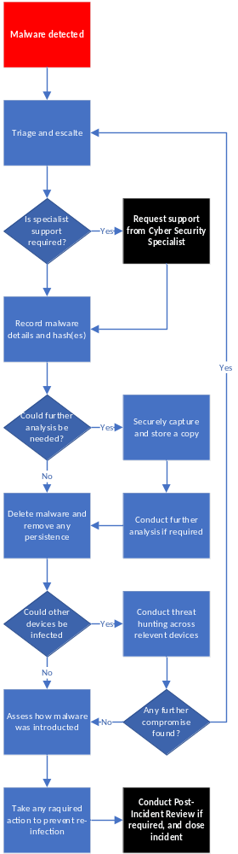
Annex A: Malware Response Flow Diagram

